41.47: a) The photon energy equals the atom’s transition energy. The hydrogen atom decays from 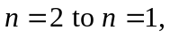 so:
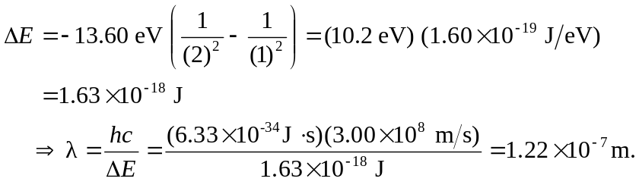
b) The change in an energy level due to an external magnetic field is just 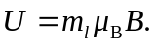 The ground state has 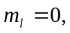and it is not shifted. The n = 2 state has 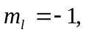 so it is shifted by
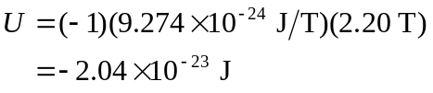
and since
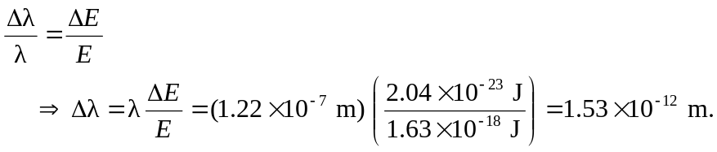
Since the n = 2 level is lowered in energy (brought closer to the n = 1 level) the change in energy is less, and the photon wavelength increases due to the magnetic field.

